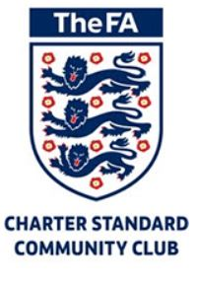
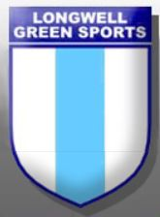

Welcome to the first edition of our Roll of Honour. We’re proud of what we do and we’re proud of all of our boy’s and girl’s. Over the years, some have played for various development centres, professional academies, professional clubs and even our National sides!
Well Done to all our coaches and managers, past and present, here is our first draft of players who have developed upwards, if you would like to add any boy’s and girl’s, please let us know and they will appear in the next edition...
Charlie Richards U11 Bristol City Academy
Joshua Whittle U9
South Glos Development
Jacob Maddox
England U16 & U17
Chelsea FC

Eddie Baker U9
South Glos Development
George Nurse
Bristol City Academy
Fin Griffiths U12
Bristol Rovers Development
Bristol City Development
Southampton Development
Bristol Rovers Academy

Toby Clifton
Longwell Green 1st Team
West Brom Alb FC
Liam Oswin
Southampton Academy
Longwell Green 1st Team

Tommy Sayers U9
South Glos Development
Luis Teagle U12
Southampton Development
South Glos Development
Jasmine Clifton
Bristol Ladies Academy
Bradley Burrows U9
Bristol Rovers Development
Bristol Rovers Academy
Kieran Brown
Bristol Rovers Development
Bristol City Development
West Brom Development
Jake Woodman U11
Southampton Development

Ciaran Teagle U9
Southampton Development
Bristol Rovers Development
South Glos Development
Lewis Hillier U9
Southampton Development
Frazer Harper U9
Southampton Development
Southampton Academy

Alfie Shellard-Cox U9
West Brom Development
Joe Woodman U9
Southampton Development
Robert Paget U9
Bristol City Academy
Bristol Rovers Academy
Lewis Fudge U9
South Glos Development
Jamie Jordan U11
South Glos Development

Joe Meredith U11
South Glos Development
Stuart Harmer
Longwell Green Reserves
Longwell Green 1st Team
Jack Lewis U10
South Glos Development

To be continued....
HOT OFF THE PRESS!!!
Well Done to Bradley Burrowes (U9) and Fin Griffiths (U12) who in the last month both signed for Bristol Rovers FC.
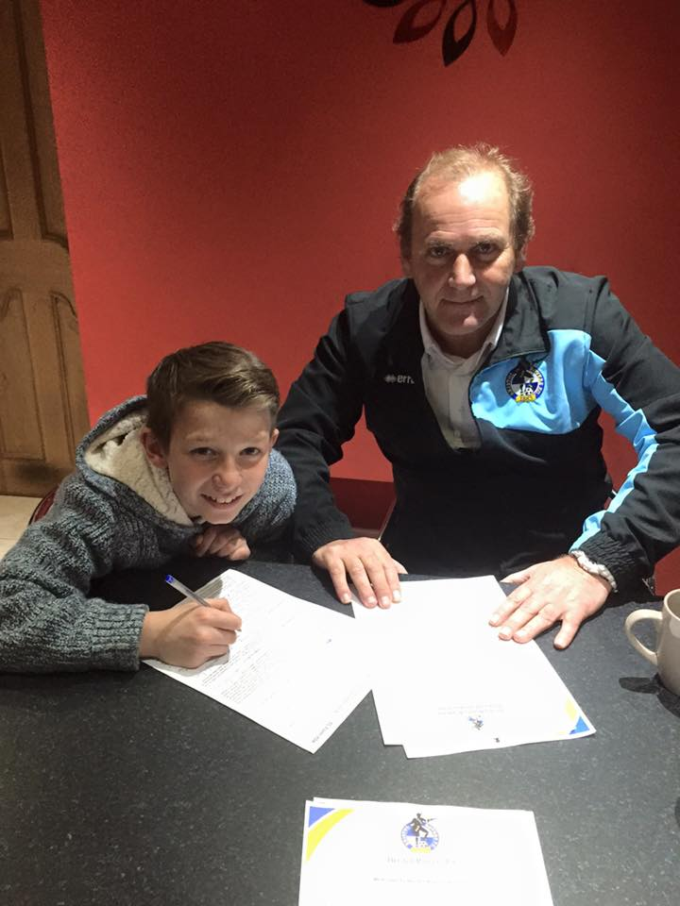
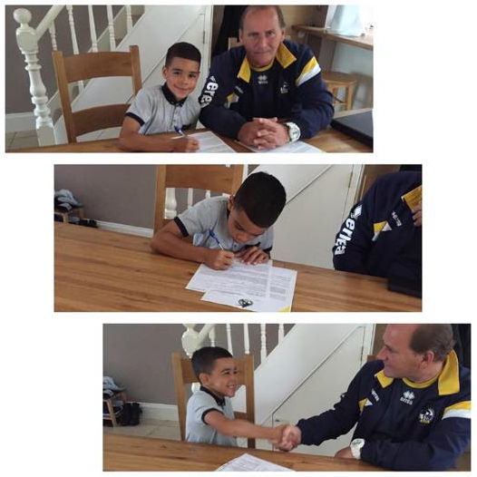

Also, did you know...
Back in 2010, the Grange School reached the final of the English Schools Cup (ESFA) and the team had 9 Longwell Green (past and present) players in the squad. They played the final at Everton's Goodison Park losing 1-0 to a school from Liverpool.
If you would like to add your players to our Roll of Honour please email our Head Coach @ nigelwhittle@sky.com

